1. Create a simple SpringBootApplication (Hello appln).

**HelloController.java**



**HelloProjectApplication.java**



**pom.xml**



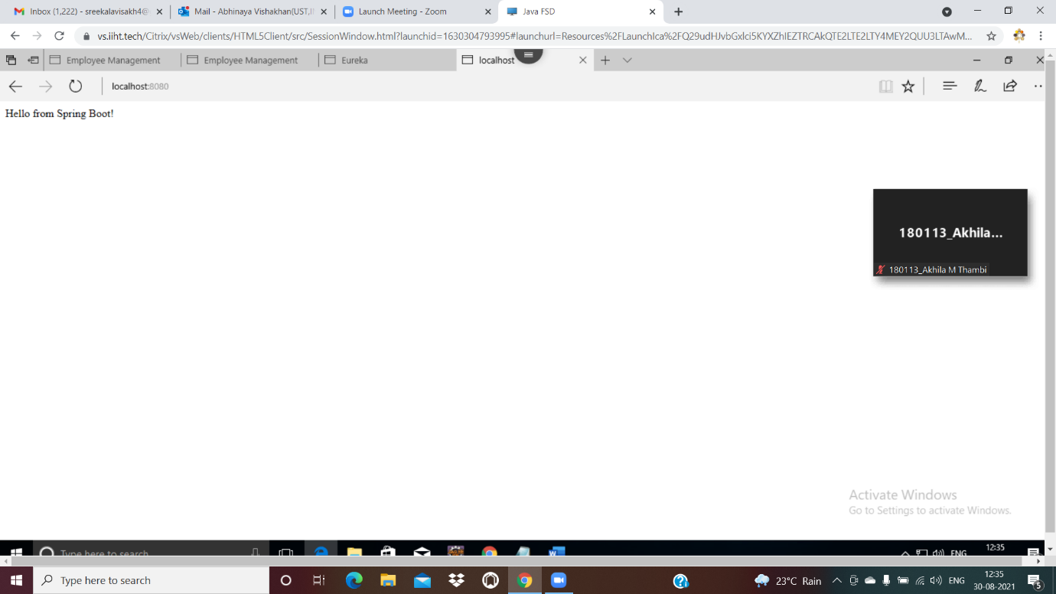

1. Create a Simple Microservice which contains one service talking to another microservice.

**Service 1-SpringA**



**Service 2-Springexample2**

pom.xml

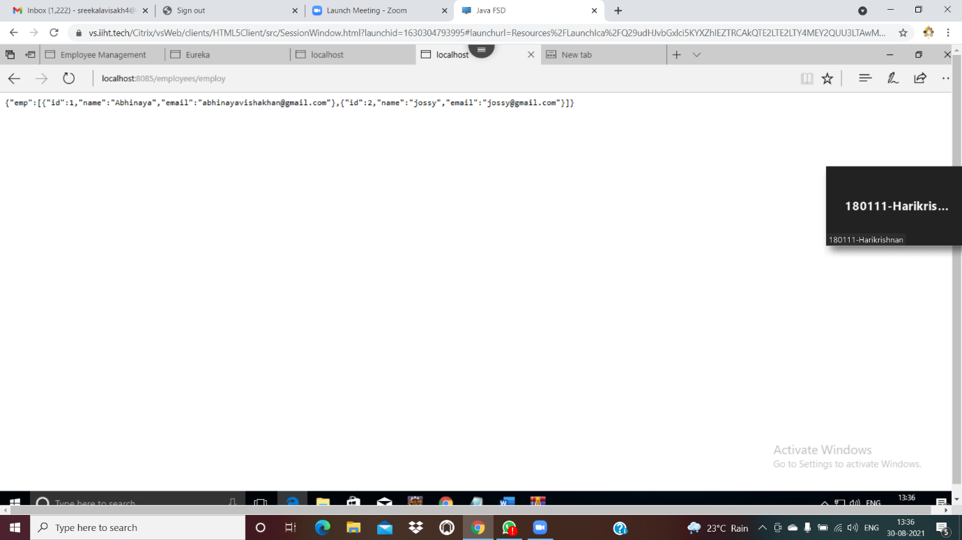

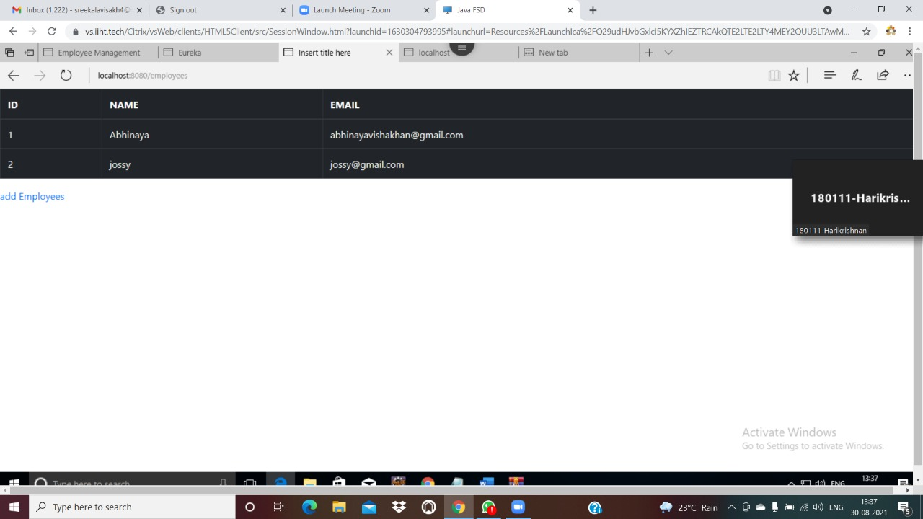

3.Create a microservice which has a fallback mechanism



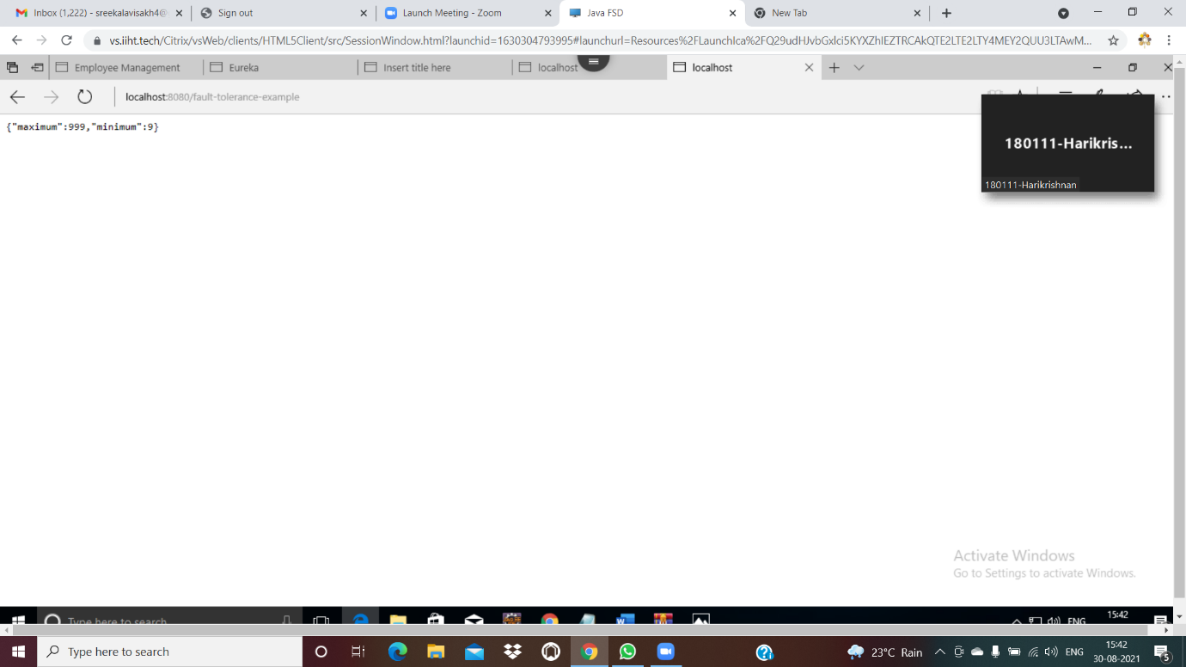

4. Create a microservice which uses Ribbon mechanism.

Currency-conversion -service





**currency exchange service**







